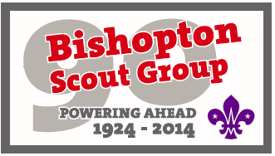
Scout Section Tour
Monday 13th July
12:00 - 2 coaches depart Site (Aberfeldy High School)
14:00 - Arrive Perth Academy Hall
15:00 - Swimming (Perth Leisure Pool)
17:30 - Dinner
Tuesday 14th July
07:00 - Breakfast
08.30 - Coach 1 to Inverkeithing Park and Ride
Group 1 – Walk Forth Road Bridge
Coach 2 to Longcraigs Watersports Centre, South Queesnferry
12:30 - Joint Lunch (Dalmeny House)?
14:00 - GROUP 1 – Walk Bridge to Inverkeithing
17.00 Coach 1 pick up at Longcraigs Water Sports Centre
17:15 - Coach 2 pick up at Inverkeithing Park and Ride
Both coaches to Fordell Firs, by Hillend.
18:00 - BBQ
19:30 - Activities
21:00 - 2 coaches to Cairneyhill Scout Hall
Wednesday 15th July
08:00 - Breakfast
09:15 - 2 coaches Depart Cairneyhill for Blair Drummond
10:30 - Blairdrummond
16:00 - 2 coaches Depart for Cairneyhill Scout Hall
17:30 - Dinner
Thursday 16th July
08:00 - Breakfast
09:30 - 2 coaches Depart to Kelpies
10:15 - Arrive Kelpies then walk to Falkirk Wheel
14:00 - 2 coaches Depart Falkirk Wheel for Bishopton

